**What is HTML?**

HTML is a markup language for structuring websites. It uses tags to format content and create links. HTML provides the basic structure, while CSS styles it and JavaScript adds interactivity. Together, they form the core of modern web development.

<tag>This is an HTML tag</tag>

**HTML Website base**

Every time you start to write an HTML document, your setup should look like this:

<!DOCTYPE html>  
<html>  
    <head>  
          
    </head>  
    <body>  
      
    </body>  
</html>

Let's analyze,

The first tag we see is:

<!DOCTYPE html>

This tag is a special tag that should be included in every HTML document. This is the first tag you should write when writing HTML. It does **not have a closing tag**, and all it does is **tell the computer reading the document that it includes HTML.** It literally says: The type of this document is HTML.

The next tag is:

<html> </html>

This tag should be included, and all it does is **tell the computer reading the document where the HTML code begins and where it ends**. All your HTML code should be written inside.

The next tag is:

<head> </head>

This tag is literally the head of the website. It goes inside the <html> tag. There is some content that we will be putting in this tag, but all the HTML we write in the head will not be a visual element on the website. The head tag is there to write tags that give information about the website, and it is mostly used by the actual browser, not to put visual elements on the website.

The next tag is:

<body> </body>

This tag is literally the body of the website. It goes inside the html tag, and it includes all the visual content of the website. Every element that you want to add should be written here. **You can add text, buttons, and any other element** you can think of. This is the visual part of the website that users will see.

**Paragraph**

The <p> HTML element represents a paragraph. Paragraphs are usually represented as blocks of text separated from other blocks of text.

Here is an example of a paragraph tag:

<p>Hi! I like using HTML because it is easy and intuitive.</p>

Paragraphs are block-level elements, meaning that a paragraph tag takes up the whole width of its parent element. What this means is that you cannot put paragraphs next to each other from left to right because, when you write another paragraph, it will start in a new line. You could do that with special styling, though.

One more thing to remember is that text in a paragraph is displayed in one line, regardless of line breaks. If you write:

<p>  
    Line1  
    Line2  
</p>

The paragraph will still look like this: Line1Line2

**ID Attribute**

Every element in HTML can have the **attribute** id. The id of each element is unique and cannot be repeated. Here is an example:

<p id="firstParagraph">My first paragraph ever.</p>

<p id="anotherParagraph">Another paragraph on the page.</p>

**Headings**

HTML headings are titles or subtitles that you want to display on a web page.

There are 6 different heading tags, but all of them follow the same principles. The tags range from <h1> to <h6>.

The <h1></h1> tag is the biggest and most important title on the website. The <h2> </h2> tag is smaller and a bit less important. This continues to the <h6> </h6> tag which is the smallest and least important title on the website. Headings are also block-level elements.

<h1>This is Heading 1</h1>  
<h2>This is Heading 2</h2>  
<h3>This is Heading 3</h3>  
<h4>This is Heading 4</h4>  
<h5>This is Heading 5</h5>  
<h6>This is Heading 6</h6>

Heading tags are **bigger than normal text and the text inside is bold.** Here is what they look like on the web:

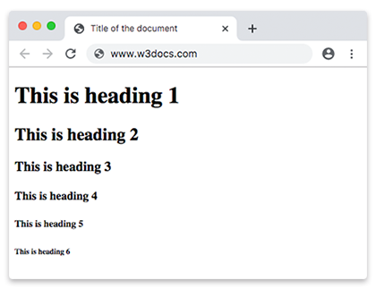

**Images**

We use the <img> tag to add images in HTML. Images are not technically inserted into a web page; **images are linked to web pages**. The <img> tag creates a holding space for the referenced image.

**NOTE:**Image tags do not need a closing tag. We do not write: <img></img>.

**Source**

In order to display images, we must add a source attribute. To add a source, we use the attribute src. The value of this attribute must be the file path of the image you are linking, or a link to the image.

Here is what an image tag would look like if we were linking one that is downloaded locally and is a part of our file system:

<img src="./images/example.png">

The . means start from the current file path, aka the file path of the HTML file. Then /images tells it to open the folder images and /example.png tells it to open the image example.png.

Here is what an image tag would look like if we were linking an image from the internet or another source:

<img src="https://picsum.photos/200">

The link <https://picsum.photos/200> is a link that generates random images.

**Alternative Text**

There is another attribute that we have, to add to image tags. That is the alt attribute.

This attribute is used when an image cannot be loaded. If the image cannot be loaded, the text inside the alt attribute is displayed instead. For example:

<img src="./images/bikeGuy.png" alt="Person riding a bike">

**Width and Height**

Image tags can also have width and height attributes, if you wish to manually change the width and height. For example:

<img id=”firstPhoto” src=<https://picsum.photos/> alt=”Hello” width=”300” height=”400”>

**Hyperlinks**

We can **link multiple pages** using a hyperlink. A hyperlink is the link that you click on to open another page.

The <a> tag defines a hyperlink, which is used to link from one page to another.

### Href

The most important attribute of the <a> element is the href attribute, which indicates the **link's destination**. Let's say you want to create a link to your LinkedIn account. Here is an example of how you can do that:

<a href="https://www.linkedin.com/company/coddy-tech/">LinkedIn</a>

The link inside the href attribute is the link the <a> tag will send you to once you click on it. The text inside the <a> tag is the actual text that will appear, the text that you can click.

### Linking to Elements

Instead of linking to another web page, we can also link to other sections of the same webpage. We can link to an element. We do that by adding a # at the start of the href value and writing the id of the element we want to link to. For example:

<h1 id="heading">Welcome to the USA</h1>  
<p id="text">Lorem ipsum dolor sit amet, consectetur adipiscing elit, sed do eiusmod tempor incididunt ut labore et dolore magna aliqua.</p>  
  
<a href="#heading">Go back to top

**Ordered List**

In order to create an ordered list, we need to learn about multiple tags.

To start creating an ordered list, we use the <ol> tag. An ordered list can have as many list items as we want. If we want to add a list item to the list, we use the <li> tag inside the <ol> tag. Here is an example of what that looks like:

<h2>Race Contestants:</h2>  
<ol>  
    <li>John Doe</li>  
    <li>Kathy Mernard</li>  
    <li>Brad Pitt</li>  
</ol>

This is an ordered list with three items inside. It would look something like this on the webpage:

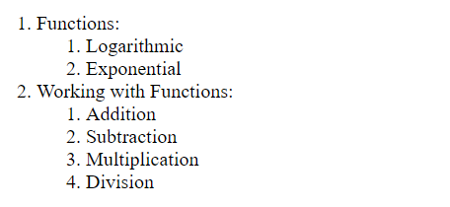

It is called an ordered list because, as you can see, the list items are ordered with numbers on the left of the text. You can also put ordered lists inside the list items. For example:

<ol>  
    <li>Functions:  
        <ol>  
            <li>Logarithmic</li>  
            <li>Exponential</li>  
        </ol>  
    </li>  
    <li>Working with Functions:  
        <ol>  
            <li>Addition</li>  
            <li>Subtraction</li>  
            <li>Multiplication</li>  
            <li>Division</li>  
        </ol>  
    </li>  
</ol>



**Type**

Changing the type attribute also changes how the items are numbered or ordered.

|  |  |
| --- | --- |
| **Type** | **Description** |
| type="1" | The list items will be numbered with numbers (default) |
| type="A" | The list items will be numbered with uppercase letters |
| type="a" | The list items will be numbered with lowercase letters |
| type="I" | The list items will be numbered with uppercase roman numbers |
| type="i" | The list items will be numbered with lowercase roman numbers |

**Unordered List**

As crazy as it sounds, an unordered list is just like an ordered list, but unordered!

We define an unordered list using the tag <ul>. We can add items to the unordered list using <li> tags.

Every item in the unordered list will be marked with bullets (small black circles) by default. Here is an example:

<h1>To Do</h1>  
<ul>  
    <li>Take out garbage.</li>  
    <li>Do homework.</li>  
    <li>Cook dinner.</li>  
    <li>Feed the dog.</li>  
</ul>

That looks something like this:

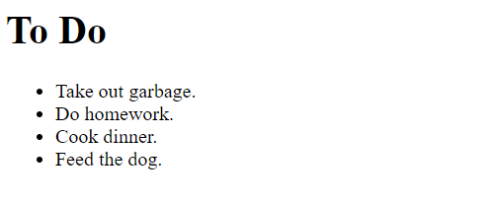

**Bold and Italic**

To make a section of text bold, we use the <strong> & </strong>tag. We can use this tag inside of paragraphs or inside of any other elements that have text.

To make a section of text italic, we use the <em>  & </em>tag.

<p> We learned about <strong>unordered</strong> lists previously. </p>  
  
<p> Maybe you would pr

**Lines**

We can add a line to our HTML page by using the <hr> tag. It does not need a closing tag.

<p>Risus nec feugiat in fermentum posuere urna nec.</p>  
<hr>  
<p>Sit amet est placerat in egestas erat imperdiet.</p>

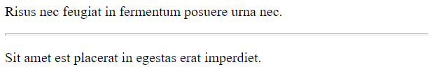

**Break**

Let's say we want to add a break to our page. Leave some room for more readability. How can we do that?

The **<br>** HTML element produces a line break in text. It does not need a closing tag It is useful if you want to go into a new line before you actually reach the end of the paragraph or if you just want some space on your website.

<p> Roses are red, <br>  
    Violets are blue, <br>  
    I don't sleep at night, <br>  
    Cause I'm thinking of you <br>  
</p>

We can also just use them straight on the page:

<p>Here's some text.</p>  
<br>  
<p>Some more text, after a break.</p>

**NOTE:**It is not recommended to use breaks like this. Try to use them as little as possible because what the <br> tag does can also be done with CSS, which is a language for styling webpages. It is much better to use styling instead.